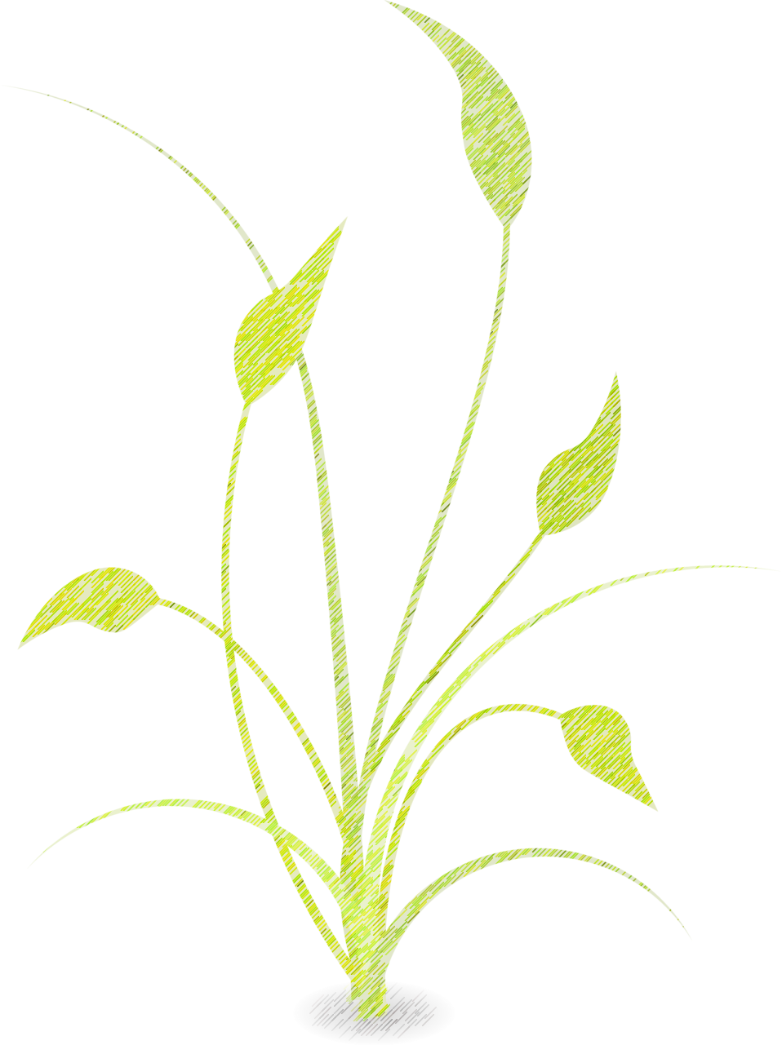
WHAT’S LOCAL ????
This Week

Gala Apples - Frecon Farms
Gold Beets- Eagle Road
Cucumbers- Cassaday Farm
Butterhead Lettuce- Gehman Family
Kale- Country Hill Produce
Summer Squash- Cassaday Farm
Scallions- Eagle Road Farm
Red Onions- Zook Family Farm
Apple Cider- Weavers Orchard
Tomatoes- Cassaday Farm
Broccoli- Sunny Harvest

